# TITLE:

# Contributions of human activities to suspended sediment yield during storm events from a steep, small, tropical watershed

## ABSTRACT

Abstract text goes here....

## Introduction

Introduction text goes here....

## Study Area

Study Area text goes here....referring to Figure1



Figure 1. Faga'alu watershed showing upper (undisturbed) and lower (human-disturbed) subwatersheds.

### Climate

### Land Use

Land use text goes here...referring to Table 1

|  |  |  |  |  |  |  |  |  |
| --- | --- | --- | --- | --- | --- | --- | --- | --- |
| Table 1. Land use categories in Fag'alu and Nu'uuli watersheds CITATION | | | | | | | | |
| Subwatershed | Cumulative Area km2 | % | % High Intensity Developed | % Developed Open Space | % Grassland (agriculture) | % Forest | % Scrub/ Shrub | % Bare Land |
| FOREST(UPPER) | 0.9 | 48.2 | 0.0 | 0.0 | 0.1 | 82.4 | 17.1 | 0.4 |
| QUARRY | 1.17 | 63.0 | 0.2 | 0.0 | 0.2 | 84.7 | 13.3 | 1.6 |
| VILLAGE(TOTAL) | 1.78 | 95.5 | 3.2 | 0.9 | 0.2 | 85.7 | 9.0 | 1.1 |
| Fagaalu Stream | 1.86 | 100.0 | 4.6 | 1.1 | 0.2 | 84.5 | 8.6 | 1.0 |

Quarry description text goes here...Picture is of the quarry (Figure 2).



Figure 2. Photos of the open-pit aggregate quarry in Faga'alu in 2012 (Top) and 2014 (Bottom). Photo: Messina

## Methods

Methods text goes here...

## Results

### Field Data Collection

#### Precipitation

Precipitation text goes here...

#### Water Discharge

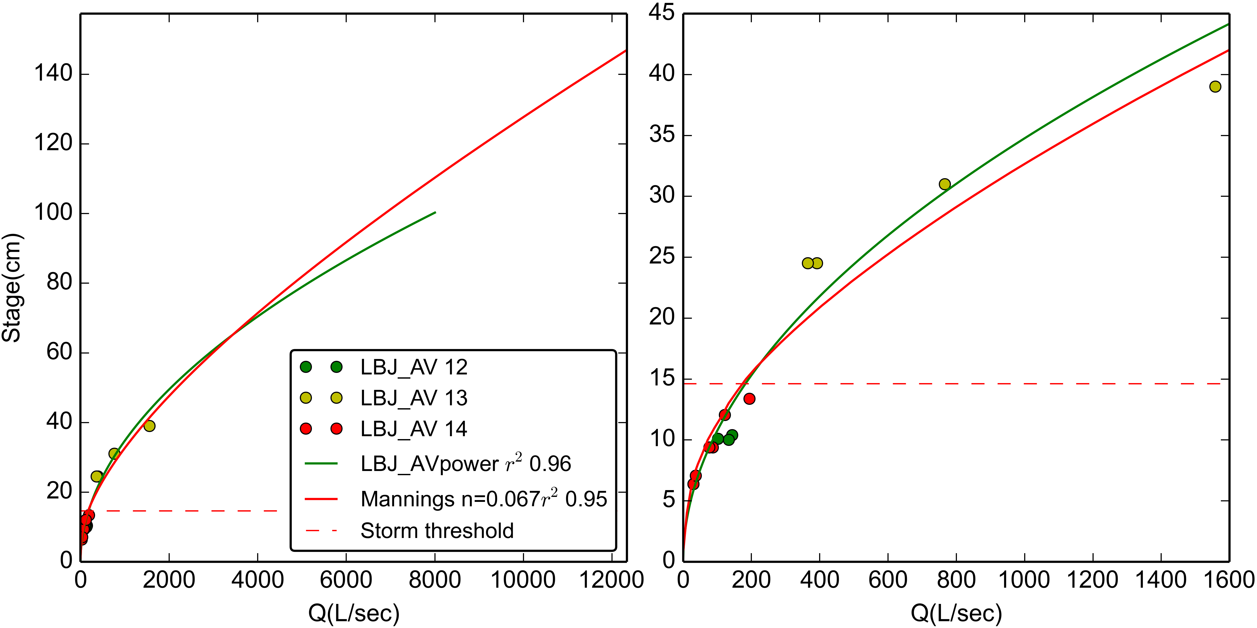

Figure 3. Stage-Discharge relationships for stream gaging site at VILLAGE.

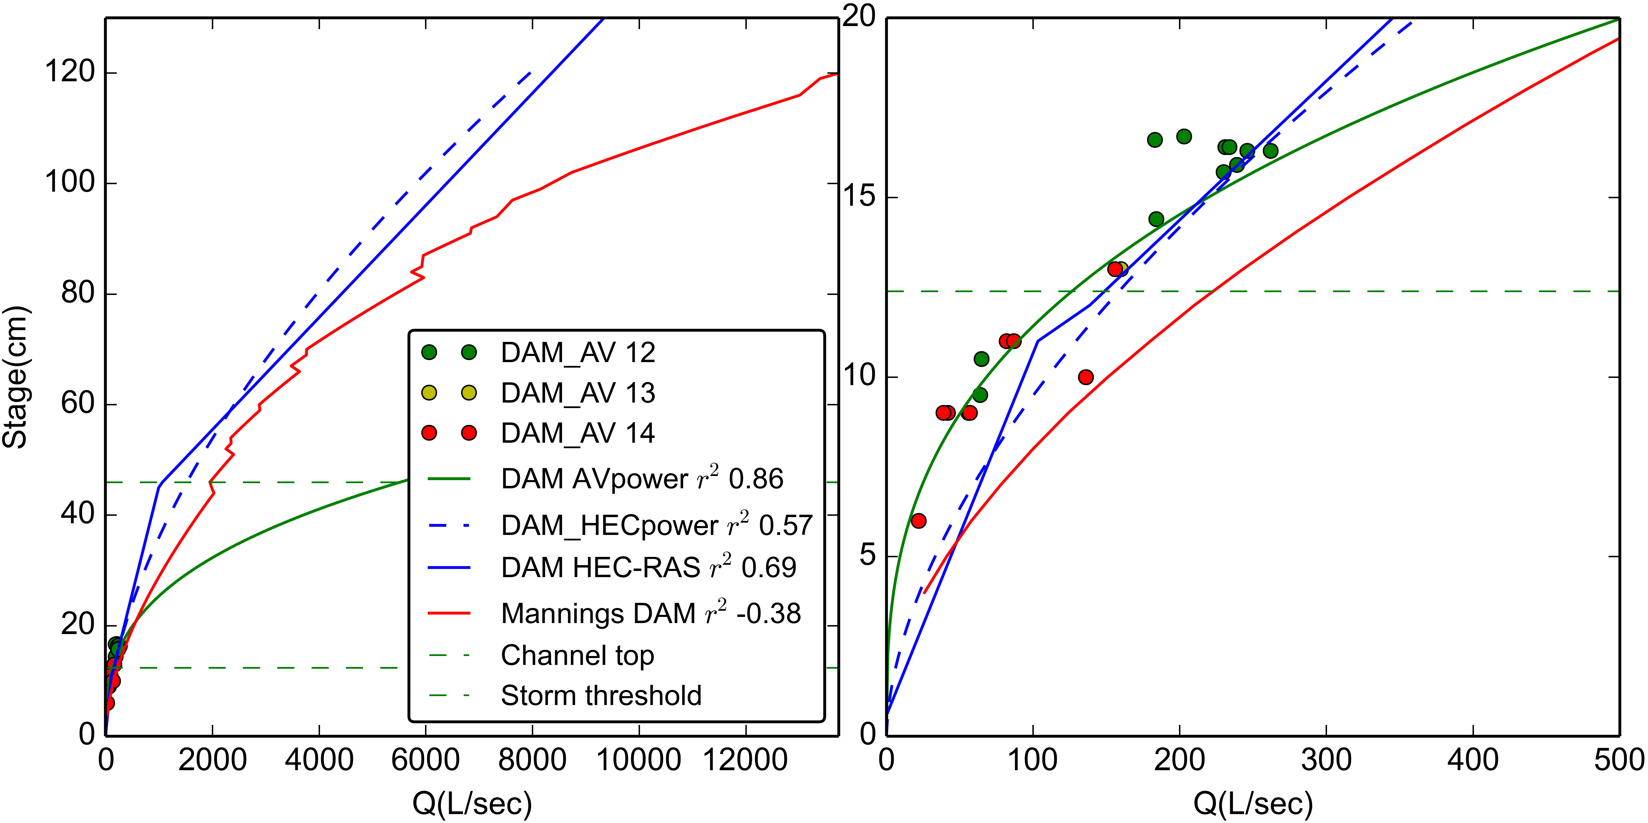

Figure 4. Stage-Discharge relationships for stream gaging site at FOREST.

|  |  |  |  |  |  |  |  |
| --- | --- | --- | --- | --- | --- | --- | --- |
| Table 2. Water discharge from subwatersheds in Faga'alu | | | | | | | |
| Storm Start | Storm# | Precip (mm) | UPPER m3 | LOWER m3 | TOTAL m3 | % Upper | % Lower |
| 2012-02-02 06:00:00 | 1 | 16 | 8277 | 13002 | 21279 | 38 | 61 |
| 2012-02-03 01:15:00 | 2 | 24 | 14229 | 20385 | 34614 | 41 | 58 |
| 2012-02-05 10:00:00 | 3 | 19 | 7983 | 11793 | 19776 | 40 | 59 |
| 2012-02-05 23:00:00 | 4 | 83 | 48860 | 65642 | 114502 | 42 | 57 |
| 2012-02-23 20:45:00 | 5 | 17 | 8088 | 9804 | 17892 | 45 | 54 |
| 2012-03-08 16:30:00 | 6 | 23 | 3552 | 2884 | 6436 | 55 | 44 |
| 2012-03-09 06:00:00 | 7 | 18 | 8870 | 7174 | 16044 | 55 | 44 |
| 2012-03-16 10:00:00 | 8 | 22 | 4247 | 5607 | 9854 | 43 | 56 |
| 2012-03-17 11:45:00 | 9 | 30 | 4536 | 6319 | 10855 | 41 | 58 |
| 2012-03-21 20:15:00 | 10 | 14 | 5833 | 6334 | 12167 | 47 | 52 |
| 2012-03-22 21:45:00 | 11 | 35 | 10405 | 14119 | 24524 | 42 | 57 |
| 2012-03-25 03:30:00 | 12 | 49 | 25404 | 24618 | 50022 | 50 | 49 |
| 2012-05-02 16:15:00 | 13 | 30 | 762 | 2633 | 3395 | 22 | 77 |
| 2012-05-08 04:45:00 | 14 | 25 | 2966 | 3046 | 6012 | 49 | 50 |
| 2012-05-22 18:45:00 | 15 | 33 | 12357 | 10607 | 22964 | 53 | 46 |
| 2012-05-23 07:45:00 | 16 | 88 | 103982 | 18346 | 122328 | 85 | 14 |
| 2012-05-24 20:00:00 | 17 | 34 | 40234 | 18628 | 58862 | 68 | 31 |
| 2012-05-26 01:30:00 | 18 | 40 | 32284 | 21696 | 53980 | 59 | 40 |
| 2012-06-03 10:15:00 | 19 | 19 | 12091 | 7830 | 19921 | 60 | 39 |
| 2012-06-04 00:15:00 | 20 | 49 | 32590 | 11482 | 44072 | 73 | 26 |
| 2012-06-04 14:30:00 | 21 | 52 | 48663 | 39327 | 87990 | 55 | 44 |
| 2012-06-06 21:15:00 | 22 | 12 | 7995 | 5111 | 13106 | 61 | 38 |
| 2012-06-07 07:30:00 | 23 | 10 | 9456 | 6328 | 15784 | 59 | 40 |
| 2012-07-08 02:00:00 | 24 | 33 | 3863 | 3470 | 7333 | 52 | 47 |
| 2012-07-27 02:15:00 | 25 | 28 | 1607 | 2548 | 4155 | 38 | 61 |
| 2012-07-27 20:30:00 | 26 | 2 | 1391 | 1201 | 2592 | 53 | 46 |
| 2012-08-09 03:30:00 | 27 | 36 | 14363 | 6557 | 20920 | 68 | 31 |
| 2013-03-05 18:45:00 | 28 | 33 | 3658 | 12948 | 16606 | 22 | 77 |
| 2013-03-06 09:15:00 | 29 | 21 | 7731 | 20126 | 27857 | 27 | 72 |
| 2013-03-07 14:30:00 | 30 | 34 | 23148 | 59587 | 82735 | 27 | 72 |
| 2013-03-11 02:15:00 | 31 | 43 | 17176 | 35679 | 52855 | 32 | 67 |
| 2013-03-21 13:15:00 | 32 | 15 | 1074 | 2654 | 3728 | 28 | 71 |
| 2013-03-23 11:00:00 | 33 | 1 | 540 | 4236 | 4776 | 11 | 88 |
| 2013-04-16 11:00:00 | 34 | 53 | 9476 | 25403 | 34879 | 27 | 72 |
| 2013-04-17 00:00:00 | 35 | 42 | 15630 | 38115 | 53745 | 29 | 70 |
| 2013-04-20 04:30:00 | 36 | 27 | 3867 | 18748 | 22615 | 17 | 82 |
| 2013-04-23 13:30:00 | 37 | 83 | 59162 | 28128 | 87290 | 67 | 32 |
| 2013-04-30 15:00:00 | 38 | 112 | 79137 | 35623 | 114760 | 68 | 31 |
| 2013-05-11 14:30:00 | 39 | 0 | 959 | 1840 | 2799 | 34 | 65 |
| 2013-06-05 05:45:00 | 40 | 170 | 134031 | 20593 | 154624 | 86 | 13 |
| 2013-06-16 03:15:00 | 41 | 28 | 7519 | 5181 | 12700 | 59 | 40 |
| 2013-07-17 03:30:00 | 42 | 11 | 1334 | 1274 | 2608 | 51 | 48 |
| 2013-07-17 23:00:00 | 43 | 25 | 10739 | 20923 | 31662 | 33 | 66 |
| 2013-07-19 08:45:00 | 44 | 51 | 23106 | 54199 | 77305 | 29 | 70 |
| 2013-08-05 23:45:00 | 45 | 14 | 4923 | 5259 | 10182 | 48 | 51 |
| 2013-08-10 04:30:00 | 46 | 73 | 21896 | 57456 | 79352 | 27 | 72 |
| 2013-08-15 19:00:00 | 47 | 27 | 2719 | 5881 | 8600 | 31 | 68 |
| 2013-08-16 08:00:00 | 48 | 192 | 110915 | 126802 | 237717 | 46 | 53 |
| 2013-08-19 06:45:00 | 49 | 36 | 13122 | 24668 | 37790 | 34 | 65 |
| 2013-09-01 08:30:00 | 50 | 40 | 6501 | 10338 | 16839 | 38 | 61 |
| 2014-02-14 14:45:00 | 51 | 18 | 8186 | 7593 | 15779 | 51 | 48 |
| 2014-02-15 09:00:00 | 52 | 11 | 1521 | 1807 | 3328 | 45 | 54 |
| 2014-02-18 18:15:00 | 53 | 11 | 487 | 1945 | 2432 | 20 | 79 |
| 2014-02-20 11:15:00 | 54 | 29 | 4466 | 16654 | 21120 | 21 | 78 |
| 2014-02-21 11:30:00 | 55 | 51 | 18868 | 38930 | 57798 | 32 | 67 |
| 2014-02-22 07:45:00 | 56 | 0 | 1242 | 1650 | 2892 | 42 | 57 |
| 2014-02-24 05:30:00 | 57 | 20 | 1298 | 1822 | 3120 | 41 | 58 |
| 2014-02-25 21:15:00 | 58 | 60 | 21531 | 50910 | 72441 | 29 | 70 |
| 2014-02-27 02:00:00 | 59 | 35 | 21133 | 25064 | 46197 | 45 | 54 |
| 2014-03-06 19:15:00 | 60 | 43 | 14636 | 20282 | 34918 | 41 | 58 |
| 2014-03-13 12:30:00 | 61 | 14 | 3095 | 4164 | 7259 | 42 | 57 |
| 2014-03-13 16:00:00 | 62 | 20 | 6021 | 7580 | 13601 | 44 | 55 |
| 2014-03-14 00:30:00 | 63 | 16 | 12159 | 17707 | 29866 | 40 | 59 |
| 2014-03-14 18:00:00 | 64 | 11 | 1088 | 2170 | 3258 | 33 | 66 |
| 2014-04-01 08:45:00 | 65 | 32 | 640 | 4595 | 5235 | 12 | 87 |
| 2014-04-06 12:30:00 | 66 | 54 | 15600 | 30873 | 46473 | 33 | 66 |
| 2014-04-08 14:30:00 | 67 | 19 | 2851 | 6040 | 8891 | 32 | 67 |
| 2014-04-09 23:30:00 | 68 | 10 | 2761 | 5445 | 8206 | 33 | 66 |
| 2014-04-11 09:45:00 | 69 | 6 | 998 | 2299 | 3297 | 30 | 69 |
| 2014-04-17 15:00:00 | 70 | 9 | 802 | 1958 | 2760 | 29 | 70 |
| 2014-04-18 18:45:00 | 71 | 17 | 4262 | 9356 | 13618 | 31 | 68 |
| 2014-04-19 06:45:00 | 72 | 36 | 15826 | 47596 | 63422 | 24 | 75 |
| 2014-04-25 15:30:00 | 73 | 20 | 6642 | 11828 | 18470 | 35 | 64 |
| 2014-04-26 11:00:00 | 74 | 0 | 1186 | 1530 | 2716 | 43 | 56 |
| 2014-04-27 11:30:00 | 75 | 23 | 6216 | 15953 | 22169 | 28 | 71 |
| 2014-04-28 09:15:00 | 76 | 16 | 2095 | 6699 | 8794 | 23 | 76 |
| 2014-04-28 21:15:00 | 77 | 41 | 11787 | 43250 | 55037 | 21 | 78 |
| 2014-04-30 11:45:00 | 78 | 34 | 20007 | 41709 | 61716 | 32 | 67 |
| 2014-05-19 13:30:00 | 79 | 25 | 3356 | 6627 | 9983 | 33 | 66 |
| 2014-05-20 01:00:00 | 80 | 13 | 2918 | 6750 | 9668 | 30 | 69 |
| 2014-05-22 13:30:00 | 81 | 62 | 9900 | 35741 | 45641 | 21 | 78 |
| 2014-05-23 08:00:00 | 82 | 4 | 1551 | 5268 | 6819 | 22 | 77 |
| 2014-05-23 23:30:00 | 83 | 4 | 2162 | 6659 | 8821 | 24 | 75 |
| 2014-05-24 09:00:00 | 84 | 2 | 604 | 1959 | 2563 | 23 | 76 |
| 2014-05-29 14:15:00 | 85 | 3 | 1368 | 3247 | 4615 | 29 | 70 |
| 2014-06-05 19:00:00 | 86 | 76 | 17013 | 47985 | 64998 | 26 | 73 |
| 2014-06-17 01:00:00 | 87 | 16 | 5837 | 15001 | 20838 | 28 | 71 |
| 2014-07-03 10:30:00 | 88 | 59 | 8095 | 23353 | 31448 | 25 | 74 |
| 2014-07-05 06:00:00 | 89 | 36 | 13729 | 29176 | 42905 | 31 | 68 |
| 2014-07-06 20:15:00 | 90 | 17 | 1807 | 6255 | 8062 | 22 | 77 |
| 2014-07-29 06:00:00 | 91 | 568 | 323584 | 341941 | 665525 | 48 | 51 |
| 2014-10-15 12:45:00 | 92 | 17 | 2716 | 5576 | 8292 | 32 | 67 |
| 2014-10-15 17:45:00 | 93 | 17 | 5877 | 11503 | 17380 | 33 | 66 |
| 2014-11-02 03:30:00 | 94 | 16 | 3922 | 7106 | 11028 | 35 | 64 |
| 2014-11-03 17:15:00 | 95 | 43 | 25518 | 10960 | 36478 | 69 | 30 |
| 2014-11-12 09:30:00 | 96 | 1 | 977 | 3040 | 4017 | 24 | 75 |
| 2014-11-12 17:15:00 | 97 | 13 | 3182 | 10209 | 13391 | 23 | 76 |
| 2014-11-16 00:00:00 | 98 | 27 | 10840 | 21016 | 31856 | 34 | 65 |
| 2014-11-18 18:30:00 | 99 | 5 | 3324 | 8890 | 12214 | 27 | 72 |
| 2014-11-19 19:00:00 | 100 | 3 | 2241 | 6845 | 9086 | 24 | 75 |
| 2014-11-22 19:30:00 | 101 | 78 | 48962 | 24578 | 73540 | 66 | 33 |
| 2014-11-24 21:15:00 | 102 | 20 | 6570 | 7245 | 13815 | 47 | 52 |
| 2014-12-04 20:15:00 | 103 | 65 | 15835 | 42695 | 58530 | 27 | 72 |
| 2014-12-09 10:15:00 | 104 | 34 | 34531 | 9412 | 43943 | 78 | 21 |
| 2014-12-19 00:15:00 | 105 | 62 | 33251 | 26884 | 60135 | 55 | 44 |
| 2014-12-21 00:30:00 | 106 | 143 | 90980 | 104181 | 195161 | 46 | 53 |
| - | - | - | - | - | Average: | 39 | 60 |

#### Suspended Sediment Concentration

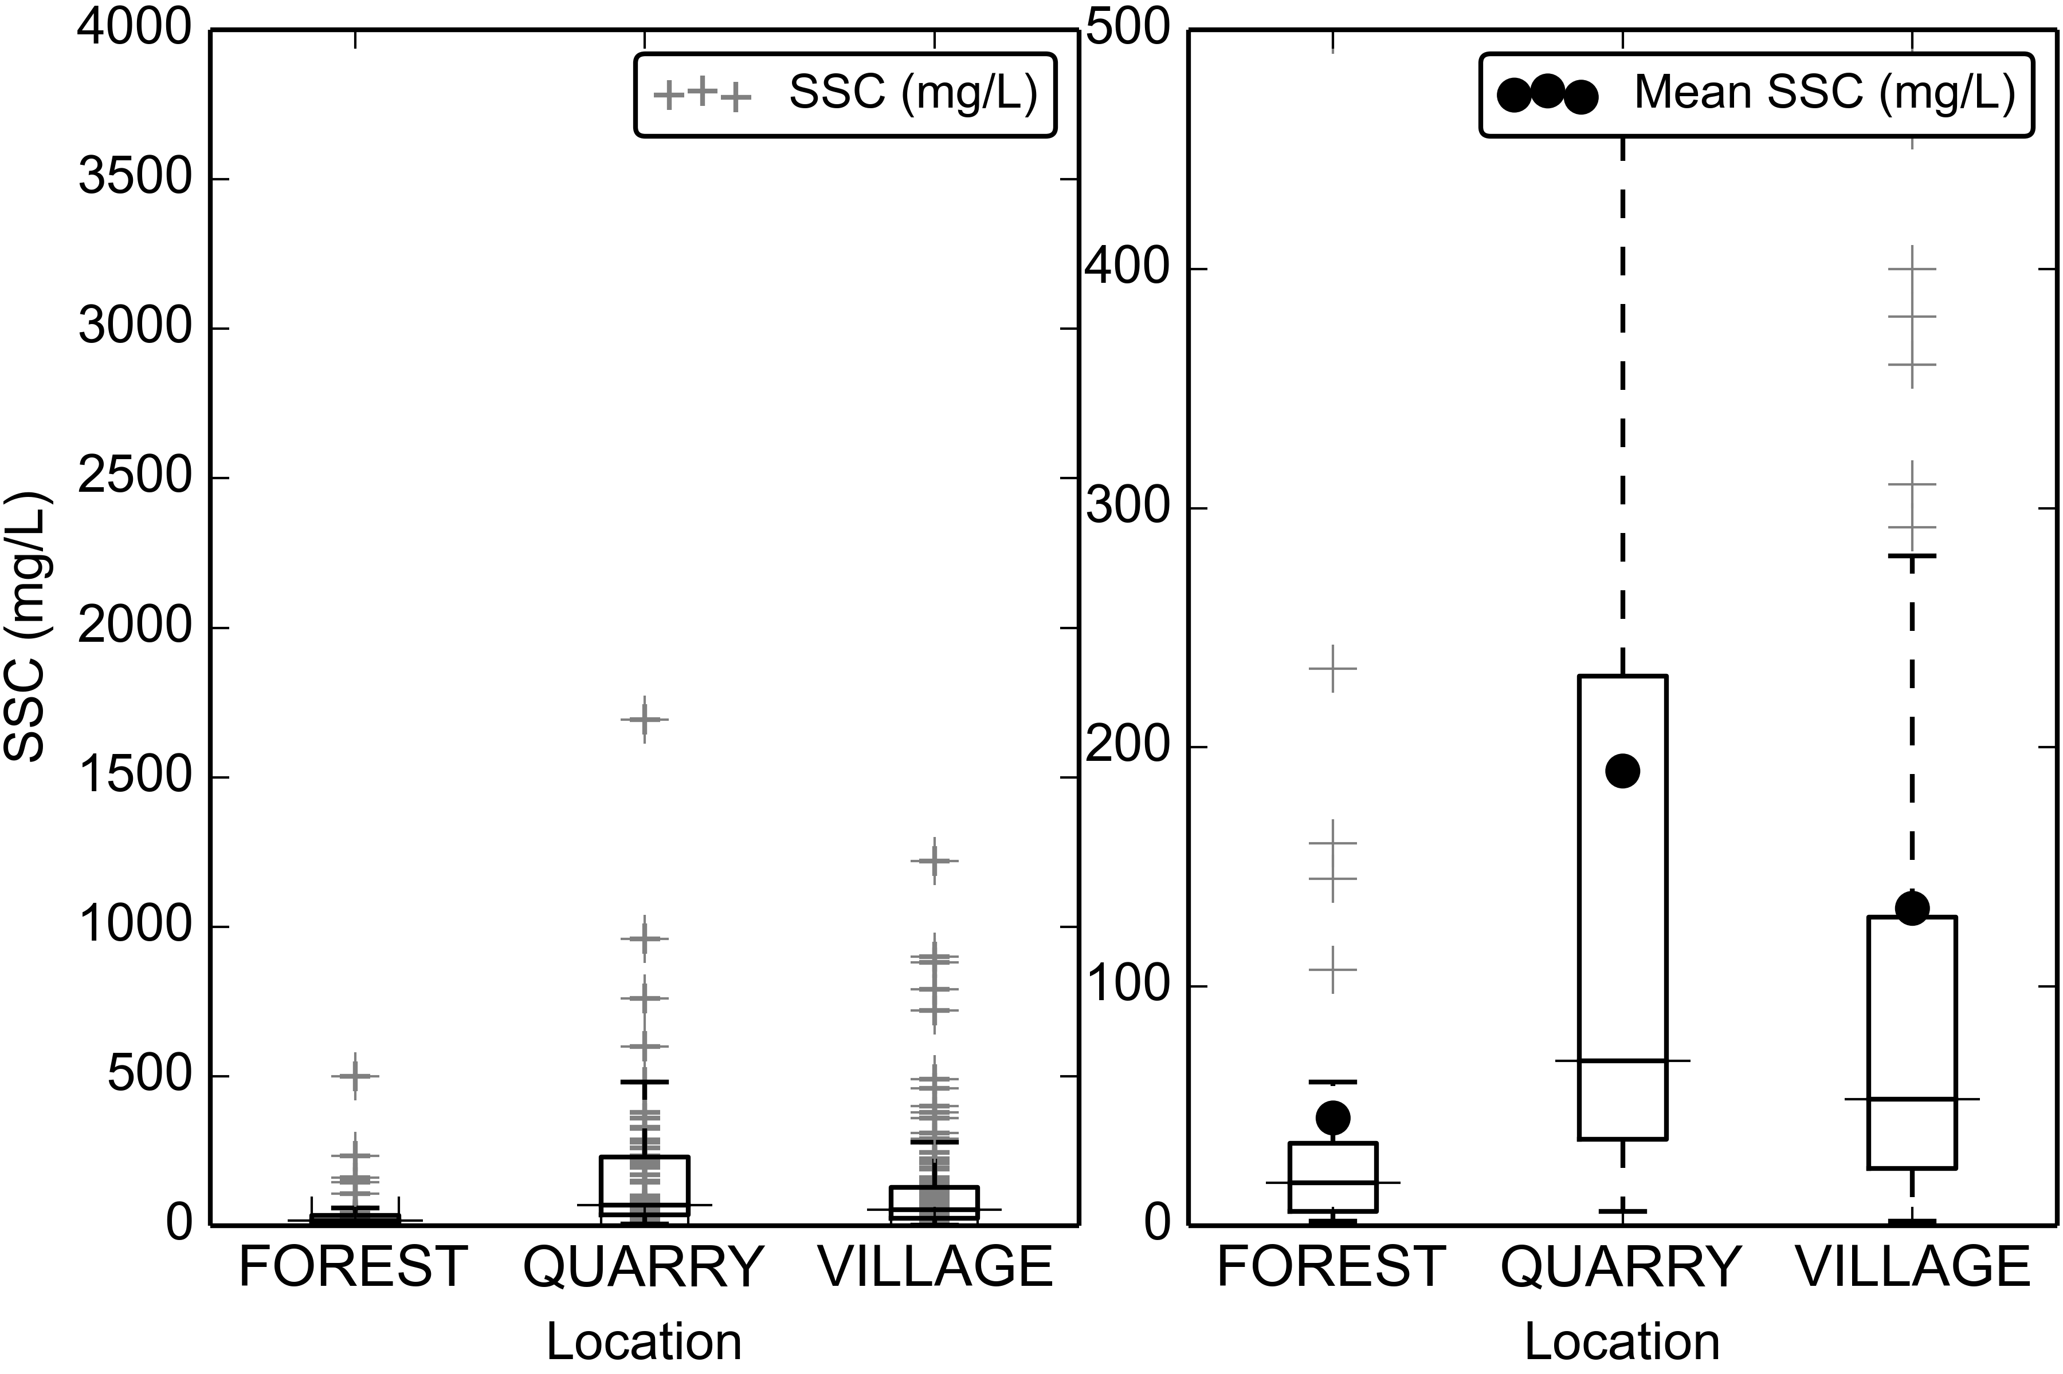

Figure 5. Boxplots of Suspended Sediment Concentration (SSC) from grab samples only (no Autosampler) at FOREST, QUARRY, and VILLAGE during storm periods.

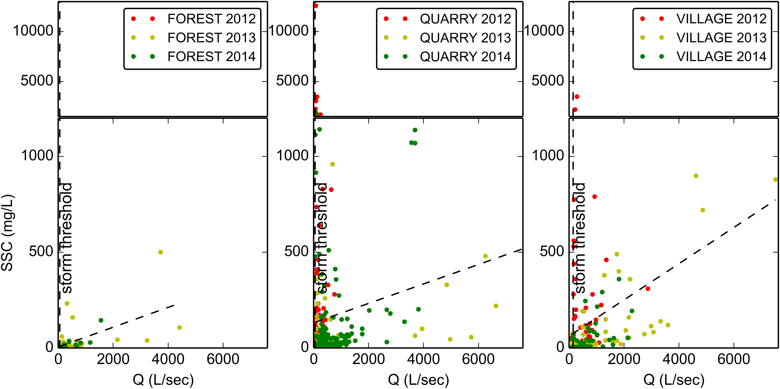

Figure 6. Water Discharge vs Suspended Sediment concentration at FOREST, QUARRY, and VILLAGE during baseflow and stormflow periods.

#### Turbidity

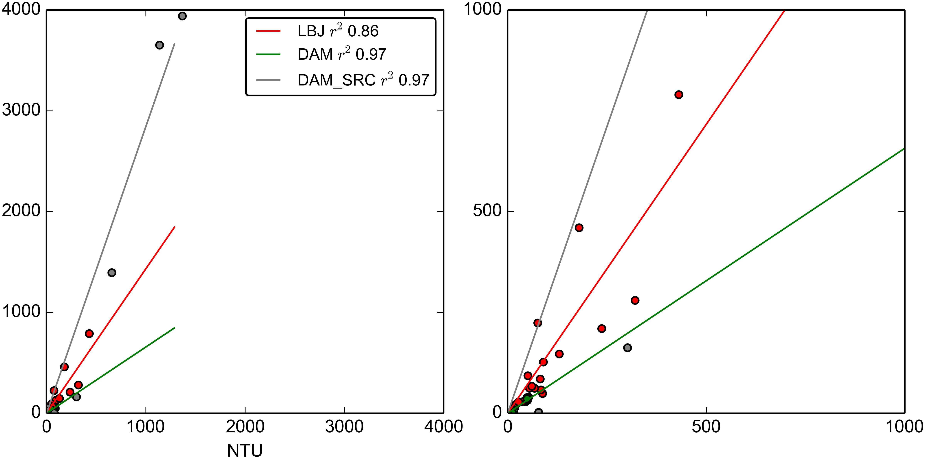

Figure 7. Turbidity-Suspended Sediment Concentration relationships for the YSI turbidimeter deployed at VILLAGE (2012-02-27 13:00:00-2012-05-23 05:15:00) and at FOREST (2013-06-13 14:30:00-2014-12-31 00:00:00).

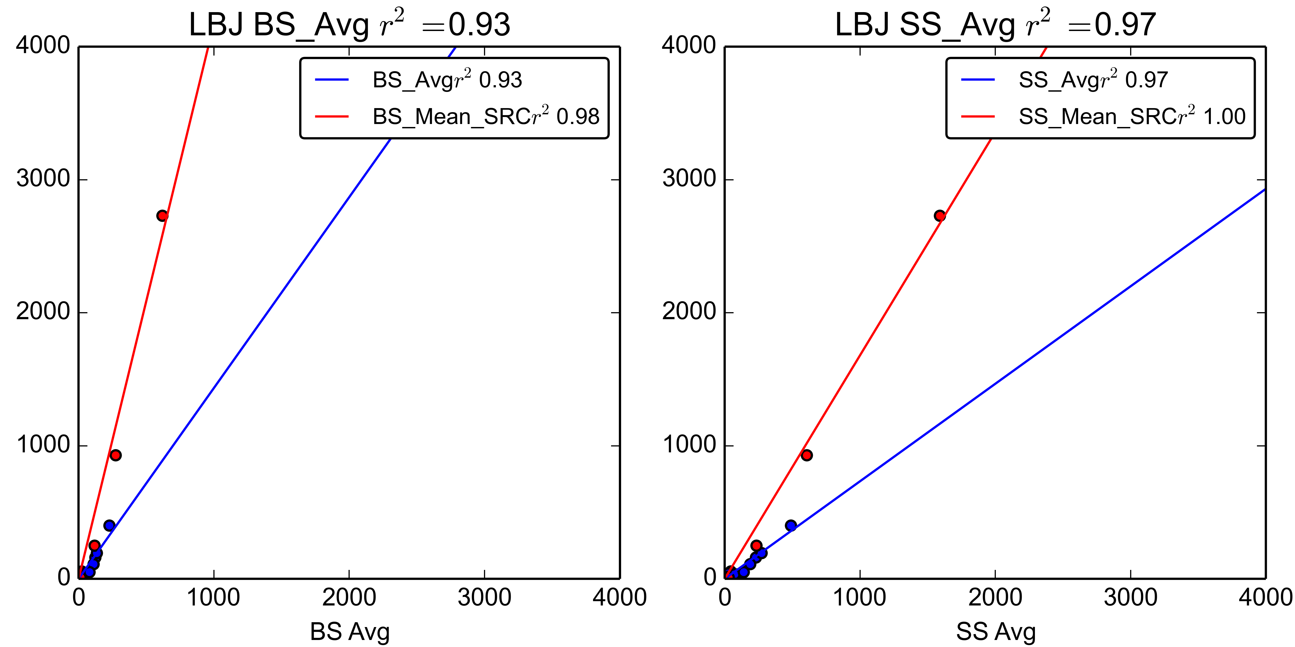

Figure 8. Turbidity-Suspended Sediment Concentration relationships for the OBS500 turbidimeter deployed at VILLAGE (2013-03-11 00:00:00-2013-07-15 14:35:00).

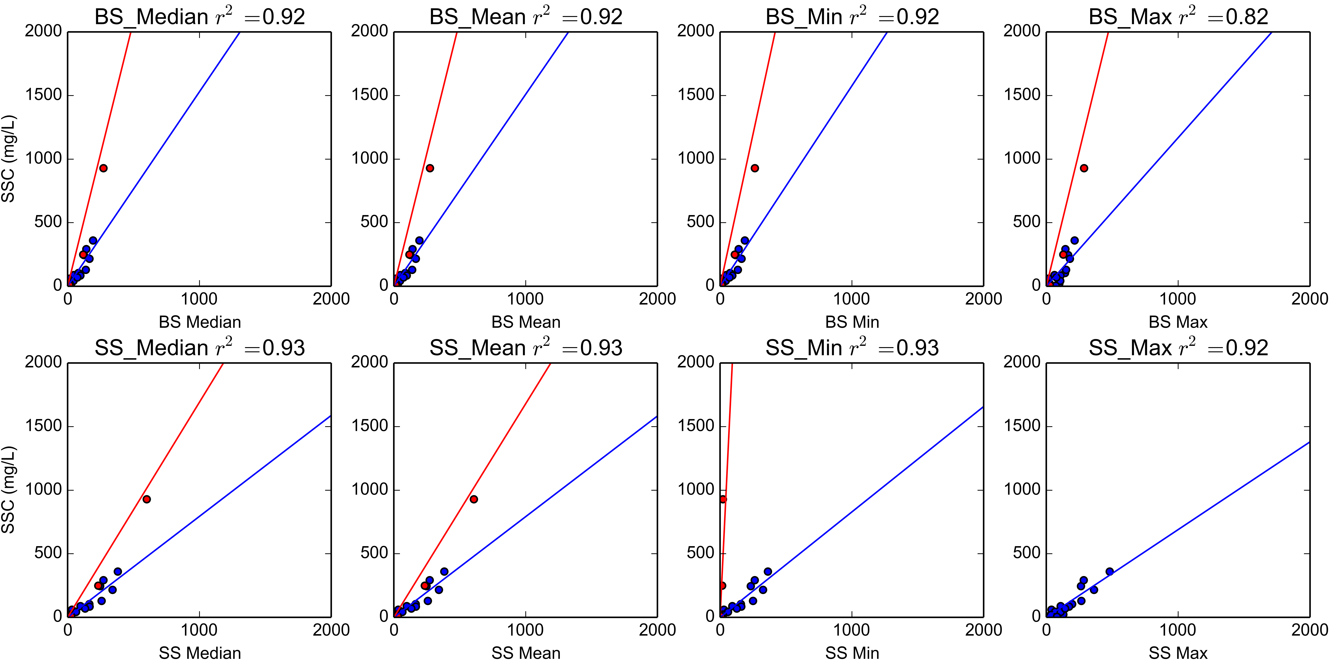

Figure 9. Turbidity-Suspended Sediment Concentration relationships for the OBS500 turbidimeter deployed at VILLAGE (2014-01-31 14:30:00-2014-03-04 09:15:00).

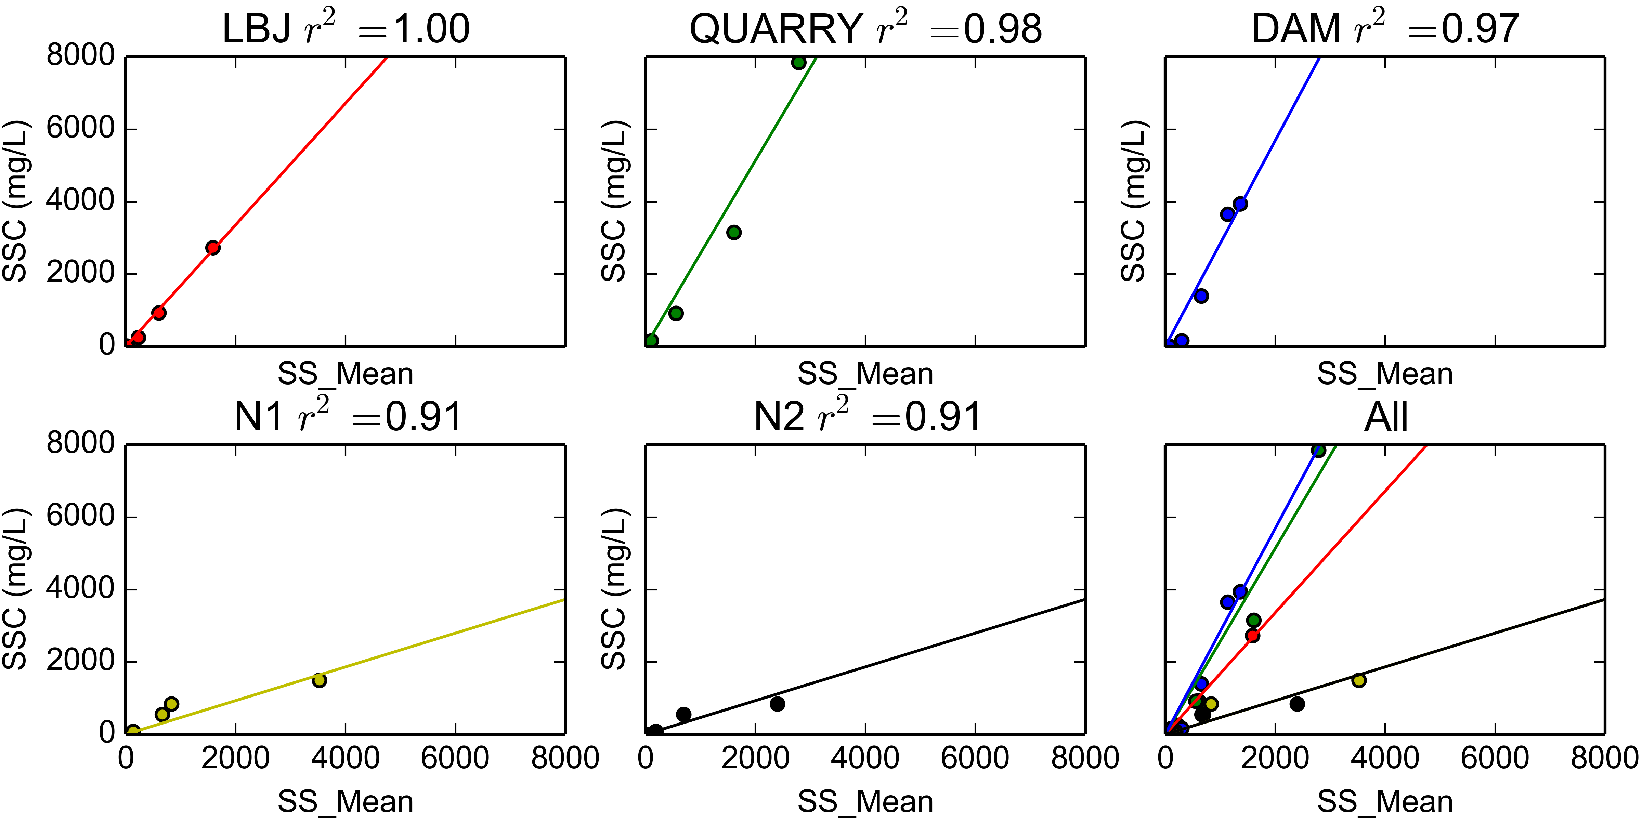

Figure 10. Synthetic Rating Curves for Turbidimeters deployed at FOREST, QUARRY, VILLAGE, Nuuuli-1 and Nuuuli-2

### Storm Events

### Comparing SSY from disturbed and undisturbed subwatersheds

Table 3 shows that lots of...

|  |  |  |  |  |  |  |  |  |  |
| --- | --- | --- | --- | --- | --- | --- | --- | --- | --- |
| Table 3. Sediment discharge from subwatersheds in Faga'alu | | | | | | | | | |
| Storm Start | Storm# | Precip (mm) | UPPER tons | UPPER PE % | LOWER tons | TOTAL tons | TOTAL PE % | % Upper | % Lower |
| 2012-02-02 06:00:00 | 1 | 16 | 0.05 | 29 | 0.82 | 0.87 | 74 | 5 | 94 |
| 2012-02-03 01:15:00 | 2 | 24 | 0.08 | 29 | 1.82 | 1.9 | 74 | 4 | 95 |
| 2012-02-05 10:00:00 | 3 | 19 | 0.05 | 29 | 0.76 | 0.81 | 74 | 6 | 93 |
| 2012-02-05 23:00:00 | 4 | 83 | 0.44 | 29 | 6.54 | 6.98 | 74 | 6 | 93 |
| 2012-03-08 16:30:00 | 5 | 23 | 0.06 | 29 | 2.28 | 2.34 | 74 | 2 | 97 |
| 2012-03-09 06:00:00 | 6 | 18 | 0.17 | 29 | 2.0 | 2.16 | 74 | 7 | 92 |
| 2012-03-16 10:00:00 | 7 | 22 | 0.05 | 29 | 1.2 | 1.25 | 74 | 3 | 96 |
| 2012-03-17 11:45:00 | 8 | 30 | 0.07 | 29 | 2.37 | 2.44 | 74 | 2 | 97 |
| 2012-03-21 20:15:00 | 9 | 14 | 0.14 | 29 | 1.01 | 1.15 | 74 | 12 | 87 |
| 2012-03-22 21:45:00 | 10 | 35 | 0.33 | 29 | 4.35 | 4.67 | 74 | 7 | 92 |
| 2012-03-25 03:30:00 | 11 | 49 | 0.63 | 29 | 7.66 | 8.29 | 74 | 7 | 92 |
| 2012-05-02 16:15:00 | 12 | 30 | 0.02 | 29 | 3.45 | 3.46 | 74 | 0 | 99 |
| 2012-05-08 04:45:00 | 13 | 25 | 0.1 | 29 | 2.84 | 2.94 | 74 | 3 | 96 |
| 2012-05-22 18:45:00 | 14 | 33 | 0.47 | 29 | 6.12 | 6.59 | 74 | 7 | 92 |
| 2013-03-06 09:15:00 | 15 | 21 | 0.06 | 26 | 0.85 | 0.9 | 35 | 6 | 93 |
| 2013-04-16 11:00:00 | 16 | 53 | 0.53 | 26 | 3.88 | 4.41 | 35 | 12 | 87 |
| 2013-04-23 13:30:00 | 17 | 83 | 9.55 | 26 | 16.86 | 26.41 | 35 | 36 | 63 |
| 2013-04-30 15:00:00 | 18 | 112 | 0.48 | 26 | 7.57 | 8.05 | 35 | 5 | 94 |
| 2013-06-05 05:45:00 | 19 | 170 | 4.69 | 26 | 34.73 | 39.42 | 35 | 11 | 88 |
| 2013-06-16 03:15:00 | 20 | 28 | 0.13 | 36 | 0.42 | 0.55 | 38 | 23 | 76 |
| 2014-02-14 14:45:00 | 21 | 18 | 0.22 | 36 | 1.54 | 1.76 | 52 | 12 | 87 |
| 2014-02-15 09:00:00 | 22 | 11 | 0.02 | 36 | 0.5 | 0.52 | 52 | 3 | 96 |
| 2014-02-18 18:15:00 | 23 | 11 | 0.0 | 36 | 0.09 | 0.09 | 52 | 1 | 98 |
| 2014-02-20 11:15:00 | 24 | 29 | 0.12 | 36 | 3.65 | 3.76 | 52 | 3 | 96 |
| 2014-02-21 11:30:00 | 25 | 51 | 1.84 | 36 | 7.71 | 9.56 | 52 | 19 | 80 |
| 2014-02-24 05:30:00 | 26 | 20 | 0.06 | 36 | 0.44 | 0.5 | 52 | 12 | 87 |
| 2014-02-25 21:15:00 | 27 | 60 | 0.53 | 36 | 6.96 | 7.49 | 52 | 7 | 92 |
| 2014-02-27 02:00:00 | 28 | 35 | 0.24 | 36 | 1.94 | 2.17 | 52 | 10 | 89 |
| - | - | - | - | - | - | - | Average: | 8 | 91 |

### Disturbance Ratio

### Comparing predictors of SSY

### Fitting sediment curves

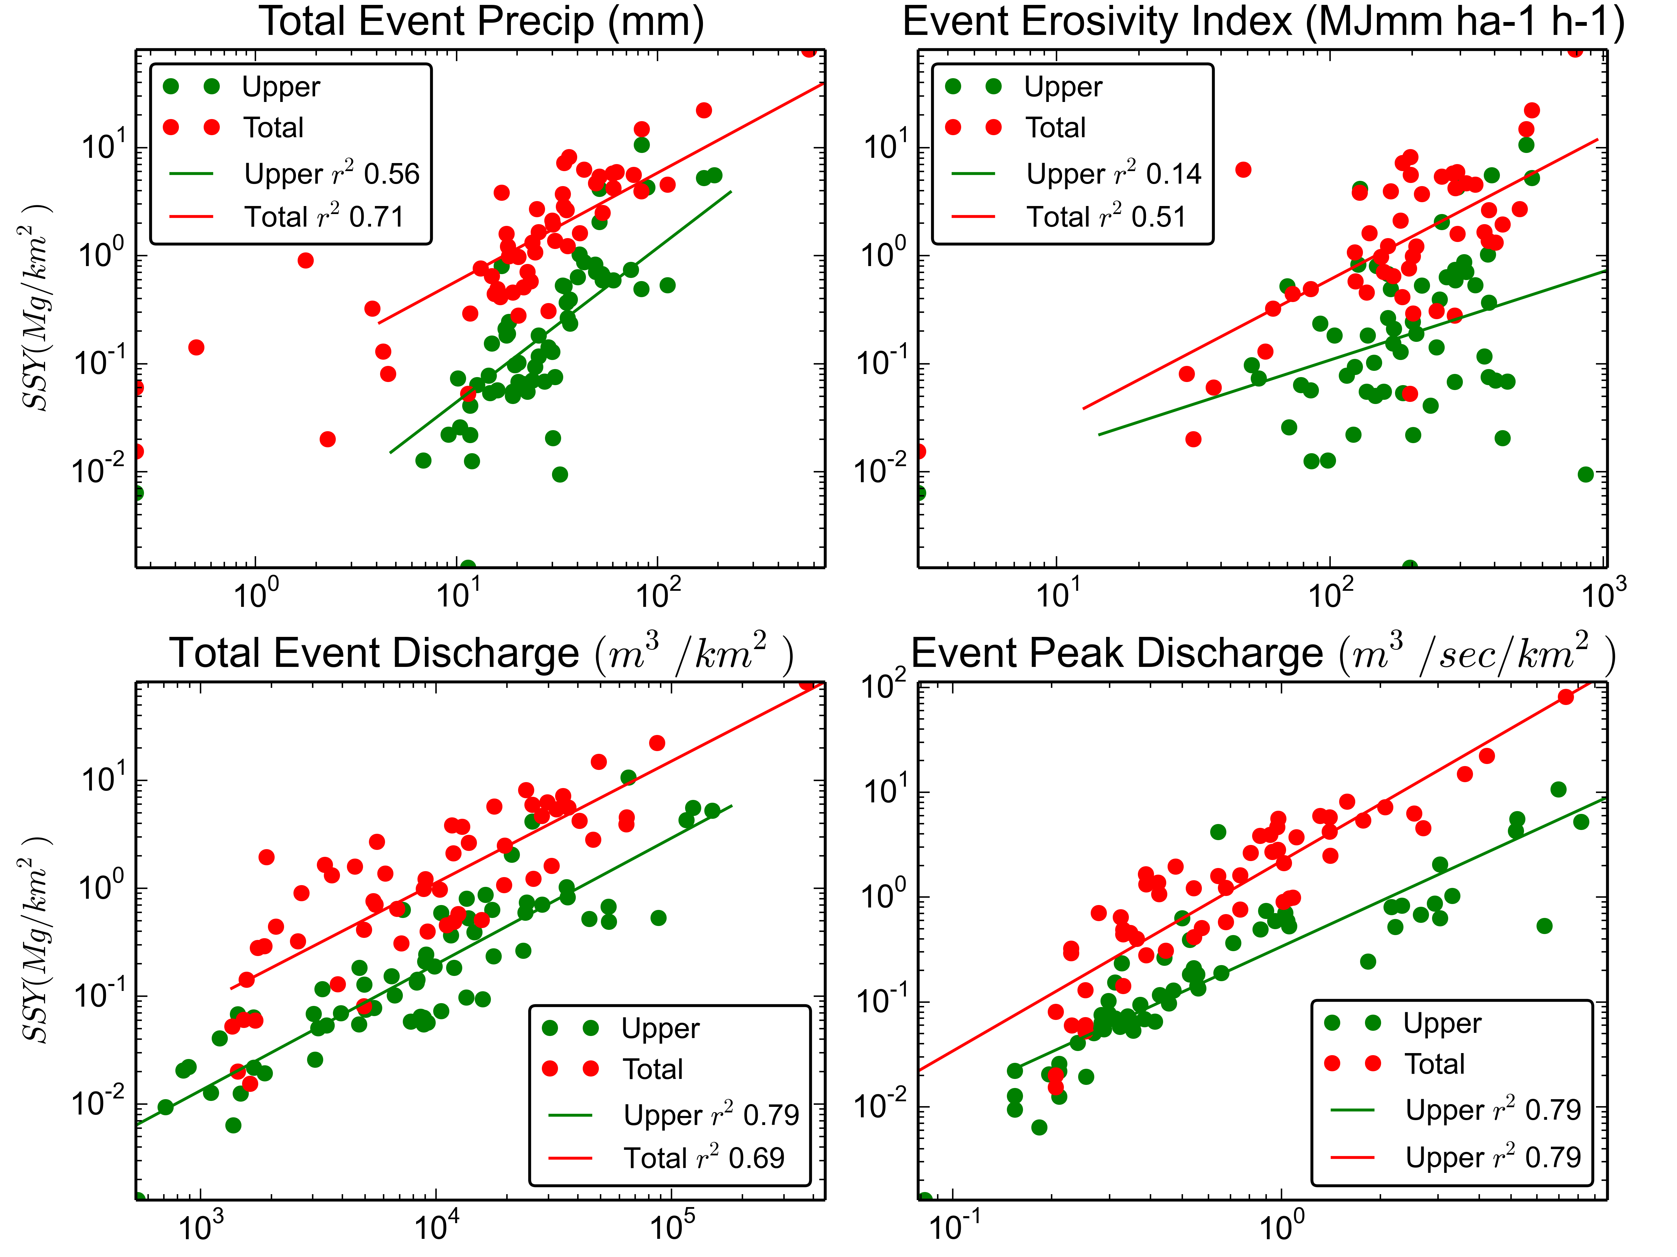

Figure 11. SSY rating curves for predictors

### Comparing human impact on SSY from Faga'alu watershed

|  |  |
| --- | --- |
| Table 4. Total Q and SSY | |
|  |  |
| Storms | 26 |
| Precipitation | 1062 mm |
| Q Forest MCM | 0.52 MCM |
| Q Forest mm | 573 mm |
| Q Village MCM | 0.94MCM |
| Q Village mm | 530 mm |
| SSY Forest | 20.5Mg |
| SSY* Forest | 22.8Mg/km^2 |
| SSY Village | 146.1Mg |
| SSY* Village | 82.1Mg/km^2 |

Humans have increased specific SSY ~360%

## Discussion

Discussion text goes here...

## Conclusion

Conclusion text goes here...